**Phase 97**

Your product wise image is right

So we need to check our product wise image is right or not

The scope of showing title is

The title should be within 25 character because in catalog ad you can only show 25 characters

SO try to mention important things for the [product which will attract the people to the product within 25 characters

You have to remind yourself that title vary with product category means woth nature of the product

Suppose our product is an electronic device let it be mouse so we will write mouse specification its color etc in it title

If they come in appearance category and clothing category then there we will mention material used color, size etc

Now in description

In description don’t use any tough language , use only natural language

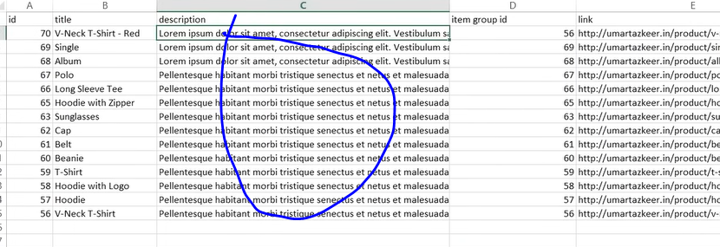

In description you tell the product related information but don’t include promotion like 50 percent off

And you can insert keywords naturally here

Teacher has seen that sometimes People in there title overcapitalize their title so don’t overcapitalize it

And in many cases in the issues in catalogue you will se it say you have overdone capitalization similarly fir description don’t use exclamation marks also

Make sure price and availability are accurate.

Price should be accurate because you have to sometimes do competitive pricing and you have to continuously check that you price or sales price are correct or not

Another thing to check is product category ensur it is correct so for that you can use ggole’s taxonomy(?)

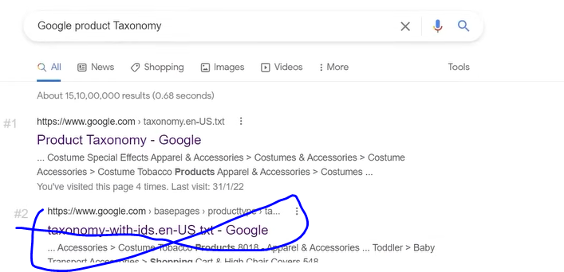

Click on the marked link

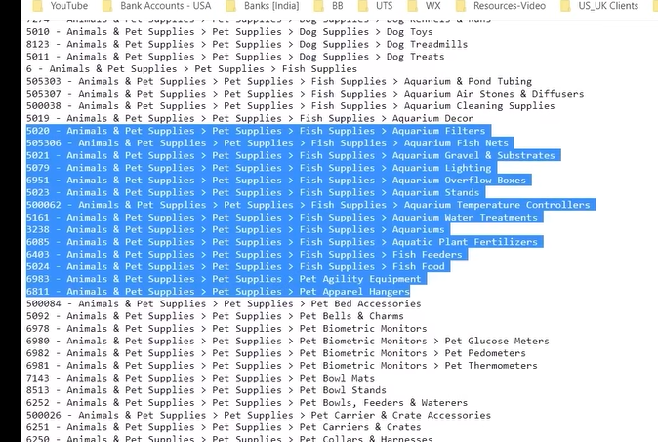

Here you get information about different product 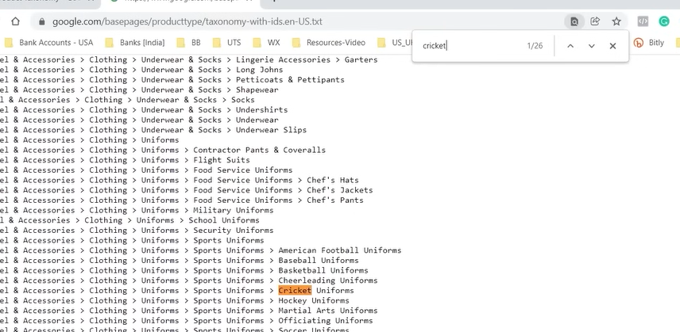

If you search here any topic like cricket now you can see different category here and we can say the associated category number so according to product make sure your product category is correct

Audit in a better way and your feed will become perfect and optimized and you will see better results

If you make only one product set then you can onlyb advertise it but if we have multiple product sets then you have different option to experiment it like if some one interacted with this product tehn show them this ad dynamically.

So The more in number , accurate and themed product set you make the more chances you have to experiment

You can remove some product from your product feed who are not profitable anymore

Whether there are more sales of them but if they are not profitable and they are not giving you ROS positive then you can terminate those product

SO these were our tips

It is not like that you just download your product information in the form of feed and we upload it in facebook system and everything will be better we need to cross check our product feed and understand that are they according to best practices or not a=If not then correct it

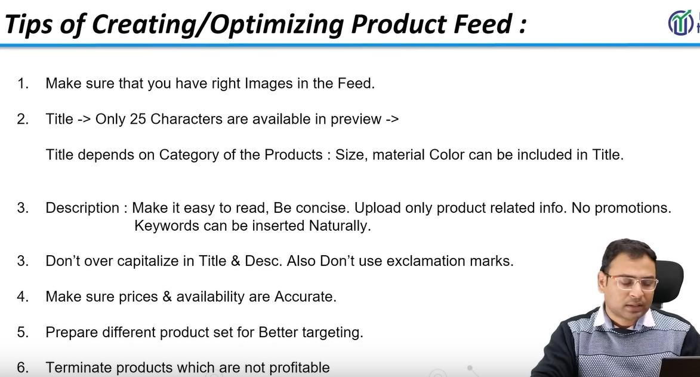

**Lesson 73:-**

In this lesson we will learn about **Automated rules in Facebook Ads**

It is very important and powerful feature that we get in facebook ad system

What is the automated tools and how to apply it and what are the different options and what are the scenerios where we can use automated tools

We can see by name that automated rules meaning to automate rules

We take a scenerio suppose we are running a campaign.

And we think that the average CPC we get cost per click we are getting is more than 3 rupees means campaign is not performing well and I want whenever my CPC go higher than 3 rupees tehn this campaign automatically get paused

We take a second scenario suppose in a campaign we have amny ad groups and inside ad groups we have many ad copies means we may have made it for testing purposes

Suppose in one of the ad copy we get 40 clicks to us it does not give us any convergence or that ad do not give any convergence so if there is such image or ad we want it to paused. So these kind of things can be done by automated rules

If we you are running big campaigns and you are testing many ad set there and you test many creatives there then it is manually not possible that you see all the creatives and see who is performing or not which ad set is performing or not. To do it manually it is very difficult and very time consuming how will you keep your eyes on everything so you decide before hand that on the basis of what you are making automated rules

You need to understand the scenario and perform action on the basis of it. That is actually automated tools now you can understand

It looks very powerful feature and it make us feel good as a marketer and we feel good that we have a capacity to automate and we will automate all the process it is not like this here ther are many things we need to keep in mind that

What benefit it can provide to us and we can use it to maximum potential and how we can optimize our campaign

There is a concept called ad fatigue

It help us to overcome Ad fatigue or we can say it avoid fatigue condition

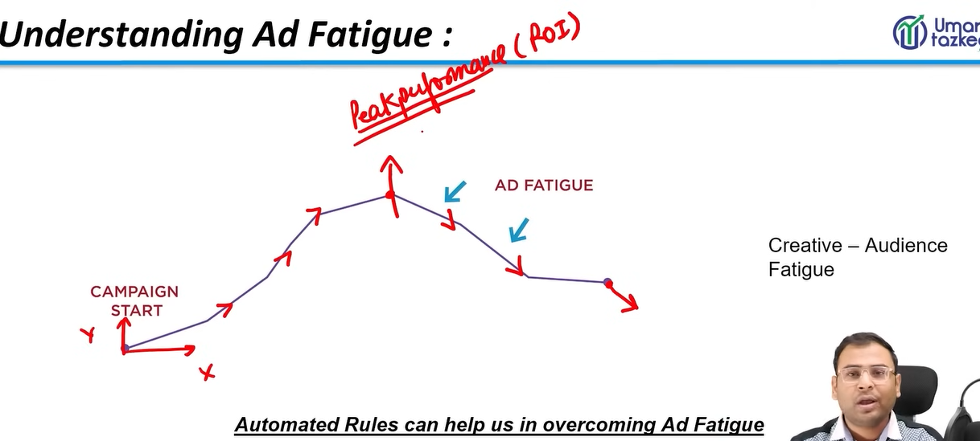

NOw in above picture you can see above there is graph and we take x axis as time and y axis a performance You will see that your campaign is performing better with time and in between it does not give better performance but still good performance and it again give better performance and you see there is peak performance we are getting good performance and we are getting good ROI you become happy and you think

**Phase 98**

That this thing will always be like thing and then you will see your campaign performance is going down and when you compare it to the peak the performance become very worse why this happens why performance go down and why this fatigue situation occurs

We are taking only one scenario as there are many scenario which can create the condition of ad fatigue. But the primary reason is that your creative become slightly old because you are showing the sa,e criteria to same type of people their frequency gets increased and their engagement get reduced with that ad so the information go to facebook system that this creative useless and the performance is not coming and your so the ad performance start going downward because frequency is increasing

If the same creative is shown to same type of people again and again then we say frequency is high so the determining factor is frequency.

We assume that if frequency is 3 or greather than it then we say there is a condition of ad fatigue

So we automate that any creative I have if its frequency is around 3 then pause that creative and we then manually inplace of that creative we use new creative

If you go manually and see each creative frequency how much it has reached and if you have applied filters that show me those creatives who frequency is 3 or more this is manual work you have to do it by going to portal or in facebook ad system you have to test many things or columns , make column of frequency then you can do it.

it can happen that the fatigue situation arises because you have not automated it and you may be working on something other so to avoid such situation we have option of automated rules

If I keep this situation that whatever campaign is live now if there frequency get increased to 3 or more then pause it

Now you can understand what they are and what type of situation they can tackle and in wht type of situation we can use it

How these rules are used and how these rules are formed

SO first we understand that these rules depend on Condition and action means in what condition an action will be performed

So the frequency more than 3 is condition and the pause of campaign is action and if frequency Is less than 2 then active it

Most of the advertising platform has automated platform whether it is google ads or facebook ads

We can apply these rules at campaign level , ad set level, ad level

Campaign level means you want to play with campaign means make the campaign active or pause

At Ad set level we set the ad set level active or pause

Before applying it practically we see some cases on what we can do

First example is that when the frequency is greater than 3 then no action take place but we will be notified about it in our email we check it whether we ant to change it or not

Another important of automated rule is that you have option that you can receive notification it is not about It is not about the action . It is also about notification

Now another example is that if we increase the daily budget by 15 percent if the conversion is more 10

Suppose if we have ad group and we are testing it and in that ad group and in that ad group there are 10 cnvergence then we allocate some budget there

So preciously it was working on budget of 1000 and then we increase it 1150 rupees. Here the thing to understand is that this option may seem attractive to us but before using it we need to research that in what situation we automation we need to perform

In small campaign where you are running on campaign with one ad set or one ad group or running with 2 or 4 images then you may need it there but it is very important

Now in another example if our CTR is less than 5 percent and cost/convergence is more than 100 then pause your campaign

Now another example is that if there is an occurance of audience of overlapping

When you make an automated rules If there are multiple ad groups and their audience are being overlapped and then ad fatigue condition occurs the auoamted rules will stop them

These are the different scenerios which you cn implement with automated rules

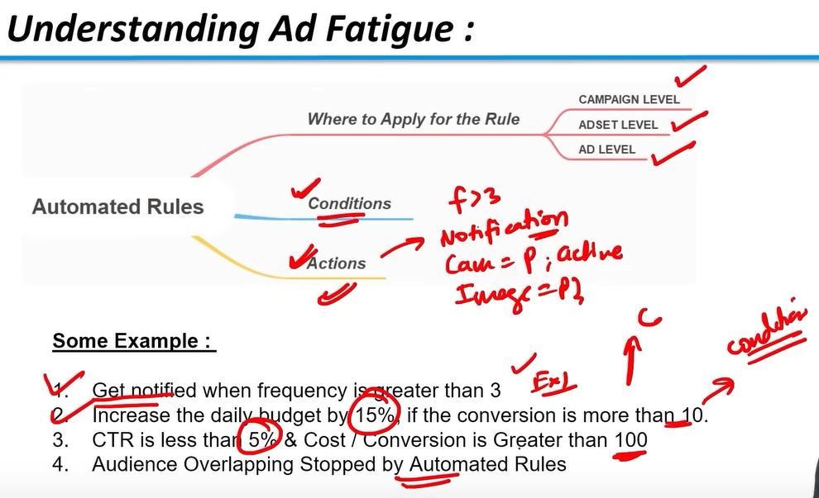

Now to do it practically go to Facebook ads and there are two ways to apply it

First way is by check the campaign where you want to apply the rules then click on more as shown below now in submenu click the Create a new rule button to create your rule on the basis of your condition

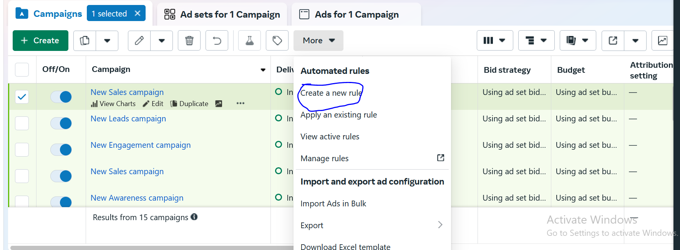

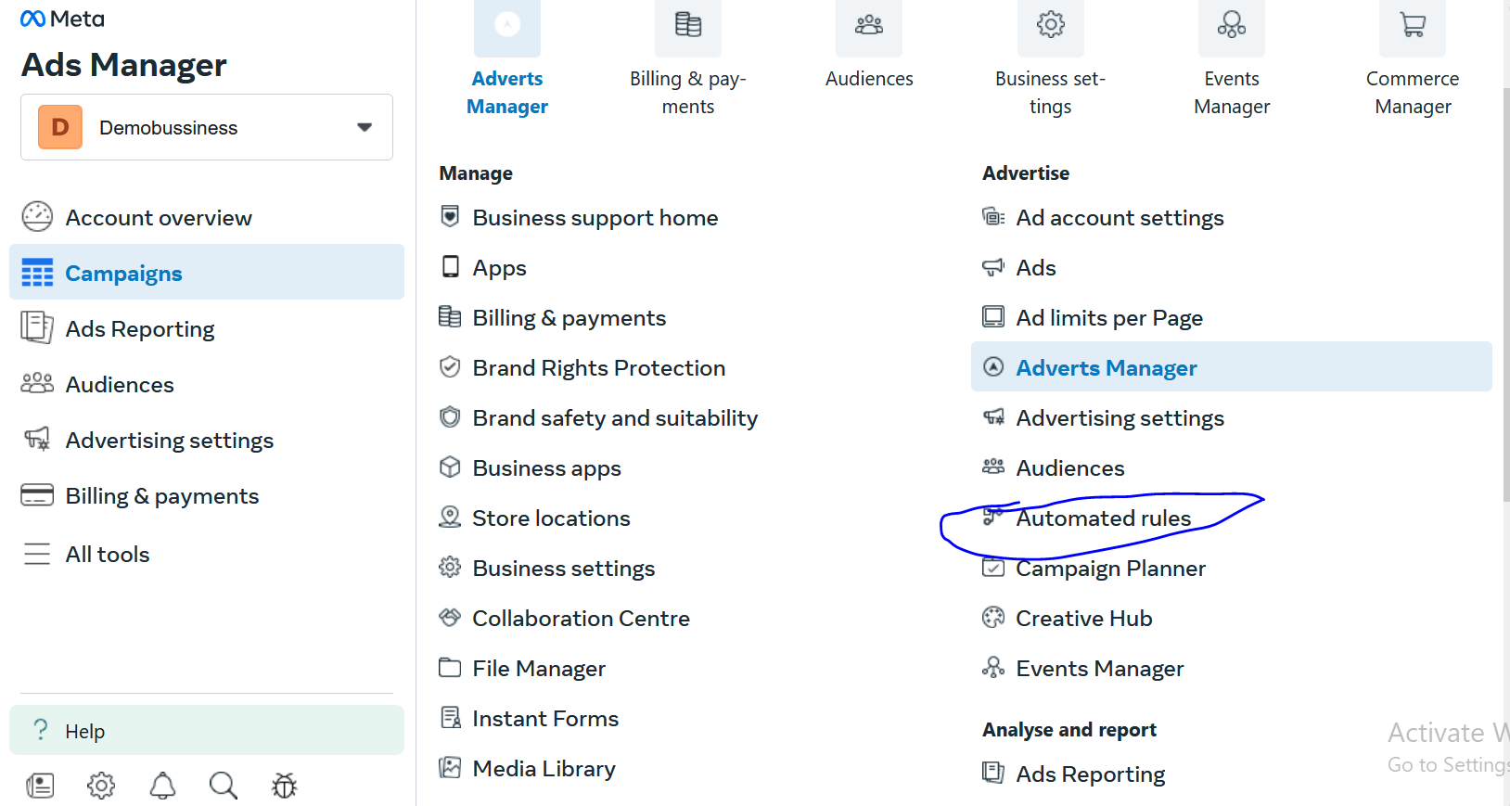

Another way to do it by expanding the side menu and then go all tools and then go to Automated rules in Advertise section

You will see the UI below

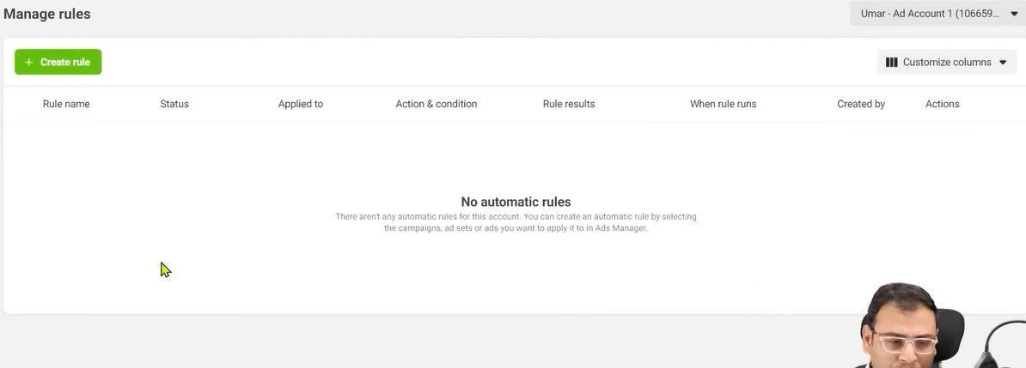

SO for this pracrical we take example of example 1 so we click on Create rule button

Now accordin to tacher perspective

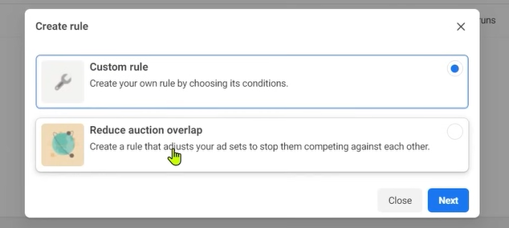

There are two oprion the fourth example will happen from the Reduce auction overlap button

But we will click on the custom rule button and then click on next but in my case it directly opens custom by clicking on new rules button but slightly different

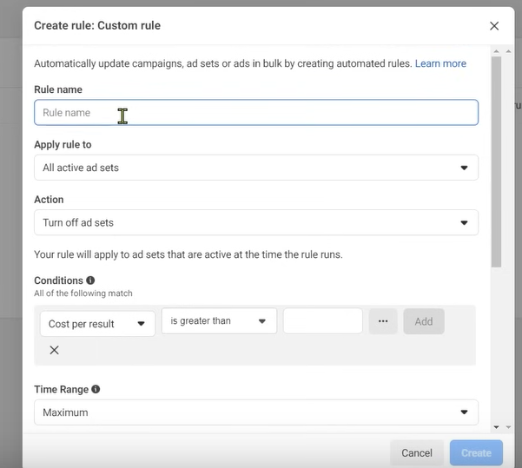

In rule name type the rule you want to make and name it according to the rules you want to apply

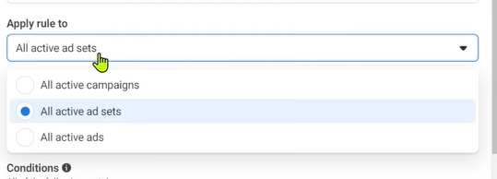

In apply rule to if you click on it then you will get three options

All active campaign

All active ad sets

All Active ads

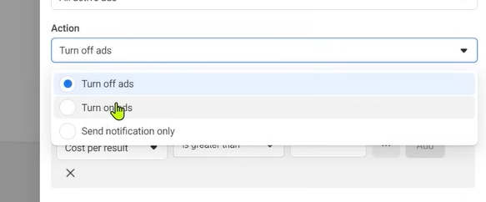

Now in action section click on it you will get three options click on Action field you will get three options

Turn off ads

Turn on Ads

Send notification only.

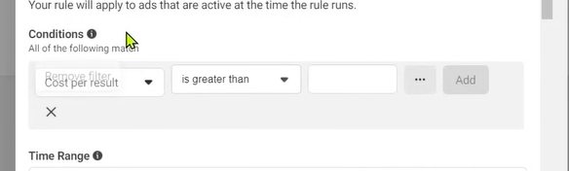

And now in condition

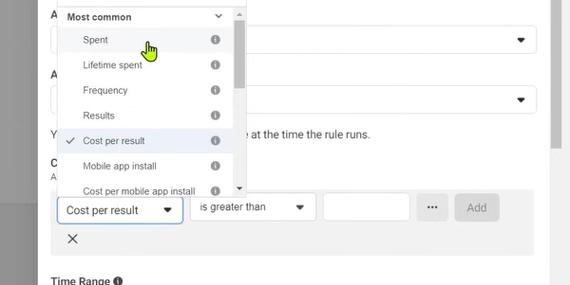

If we click on above option then we get many option but we choose frequency if not founf then type to search it

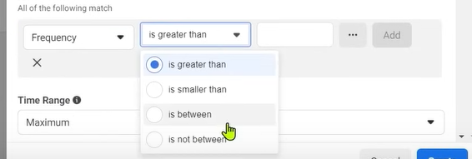

And then in next field you get options of greater,smaller, in between,is not between

Now in next field enter 3 and then click on Add button

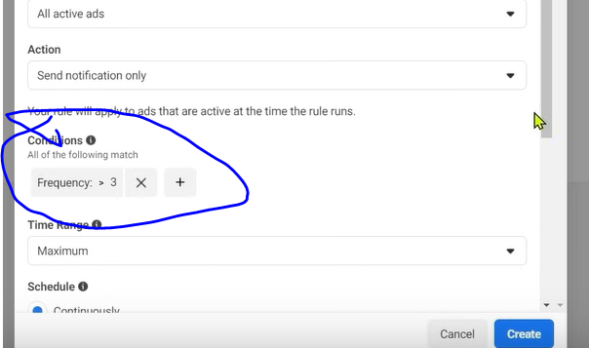

Now you will see the conditions listed as marked above

Sow e are ssyin if our ad frequency is greater than 3

You can click on + button to add one more conditions in your autiomated rules

You will see something like below

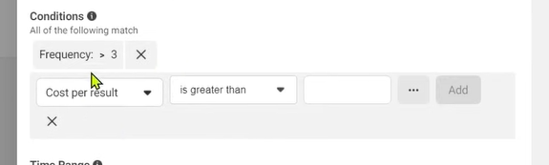

We can add another condition if we want.

**Phase 99**

You can set time range as shown below

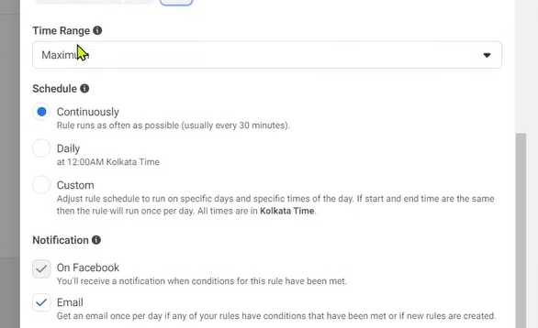

If maximum chosen then it will be valid for as long as possible

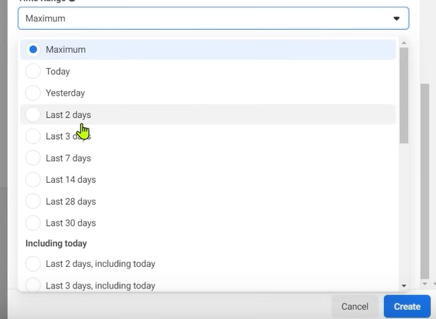

You can set it for any amount of time as shownabove (I think it is fiktering on the basis of it )

You can schedule it

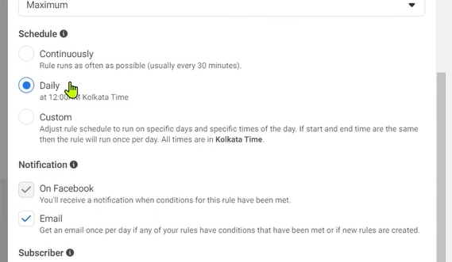

You can schedule it if chosen continuously then it will keep checking the rule and if choosen daily then it will kepp checking the rule daily at 12:00 AM according to IST

If the condition is true

Then the action will be applied means notification will be sent in our case

IN continuously it will check the rules after every 30 minutes .

You can set it to custom

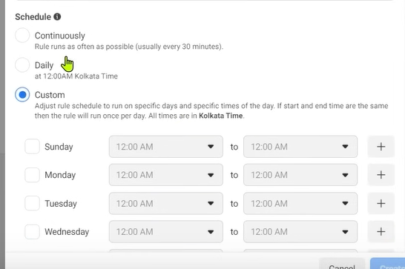

Mostly Daily and continuously is chosen

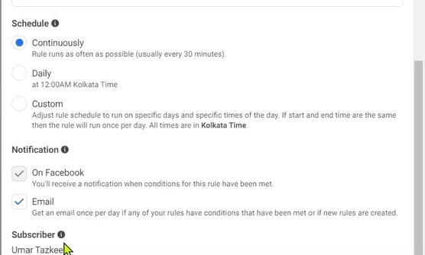

We can tell where to get the notification

(subscriber is written above)

Now click on create rule button

Now you can see your rule listed

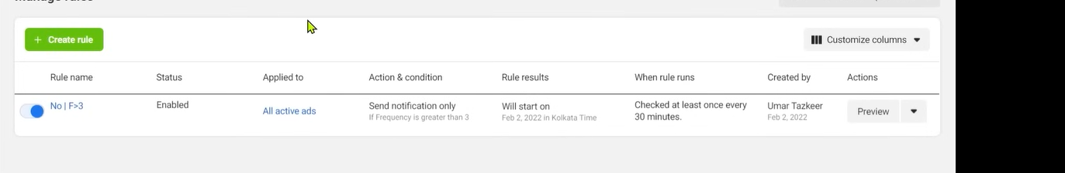

The rule is running but it is performing some action or not

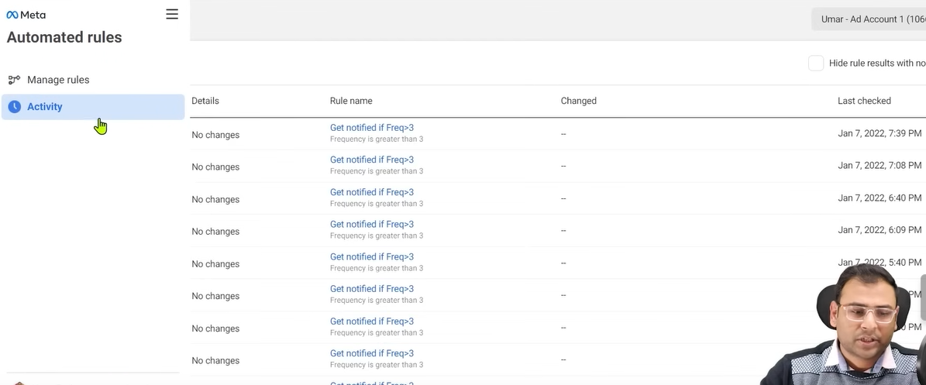

For that go to activity sectionin side menu

As shown above It will tell you when the checking happened in the list

IN details you can see No changes is written because since it is a dummy account

But if the condition is matched then the rule will be applied and you can see what changes did happen

If you made a rule and you are editing it and you are testing those rules then check what are the changes mentioned in activity

It will help you make things understand in a better way

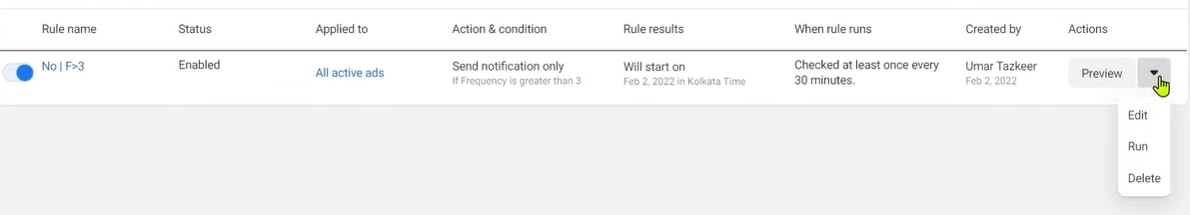

You can delete it if you want as shown above

Now we take the second example Again follow the same way and reach custom rules

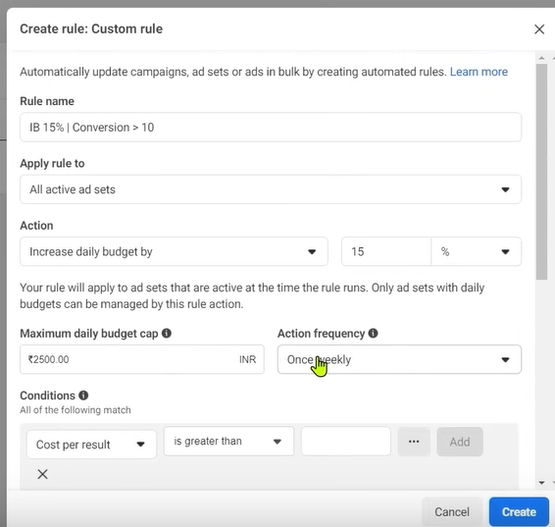

In apply rule to choose All active ad sets

And then in action choose Increase budget by and then in next field 15 and then in next percentage

And now in Maximum daily budget cap you can set the maximum limit to which the budget can increase

In action frequency you can check how frequently checking can happen(I don’t know)

You can choose one hourly or once weekly as well and many more

In condition we choose purchase(Mets Pixel ) and then in next field choose is greater than and then in next type 10

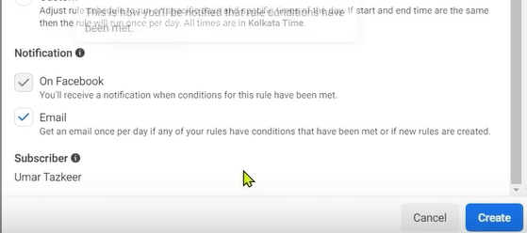

You can tell whether you want to receive the Email or notification

We should create rules which will make our process easy and make our optimization easy

Now we will see fourth example of overlap

WE can manage audience overlap by rules

If audiecn overlap happens then auction overlapping will also happen

Because same audience is present in both the ad set and we are auctioning for same people twice

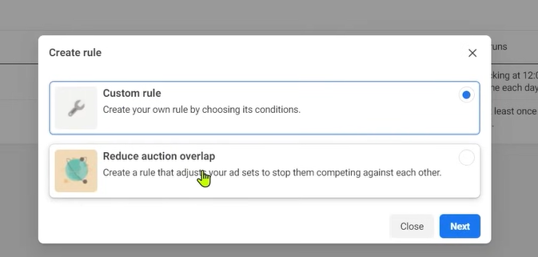

So this time we choose second option then click on next button as shown above 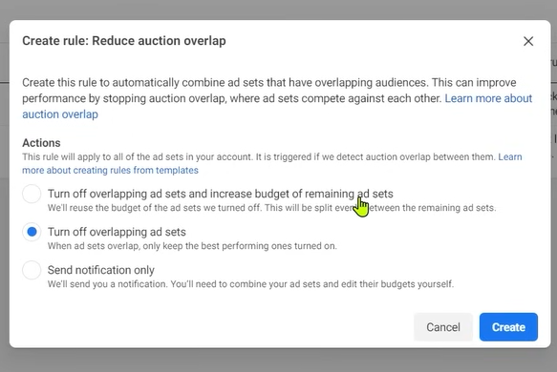

Now you get three option first is

Turn off overlapping ad set and increase the budget o remaining

The above means if there are 5 ad set and two of them are overlapping and increase budget in the remaining three

And the second option is  
Turn off overlapping ad sets

In thir you choose send notification only

Now click on create button

It is not asking some setting it is automatically creating it because this is a condition which is very common and it can come

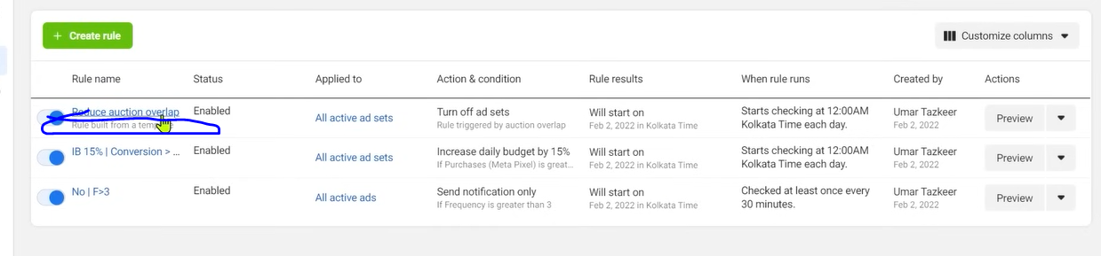

Noew you can see in the list it is written Rule built fro a template due to which it is automatic

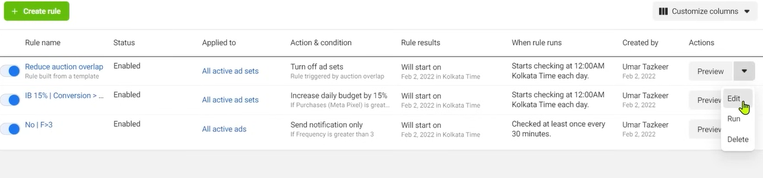

If you want ot see how does it work you can follow the setps shown above

Click on edit button Now it will below

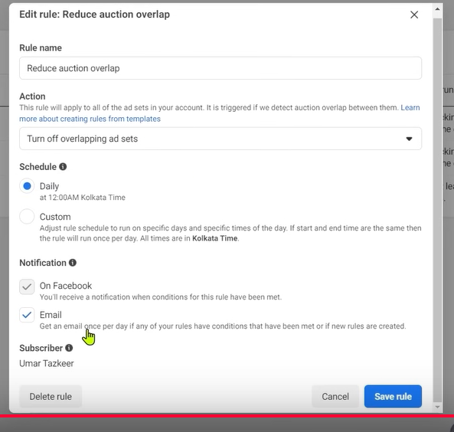

You can see the details and edit it

How id these rules are being applied you can check in the activity and what activity the rules are performing

Now it may not look a normal option to you

Now you can understand that if we use automated rules in full potential form then we can do many optimization and we can automate optimization

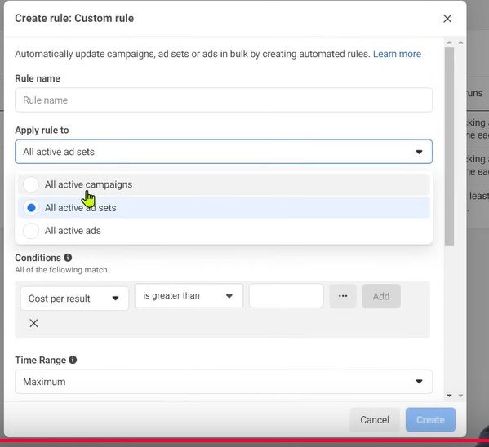

Now you may see when you create a rule then you cannot apply rule to any individual campaign but to all campaign same for ad sets and ads.

For that you need follow the first way to create rule

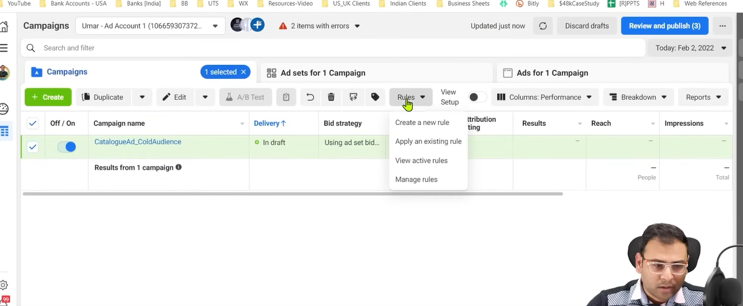

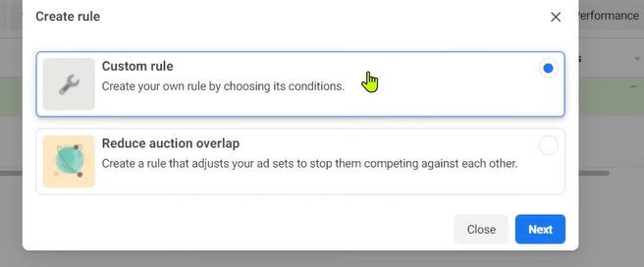

Now choose custom rules

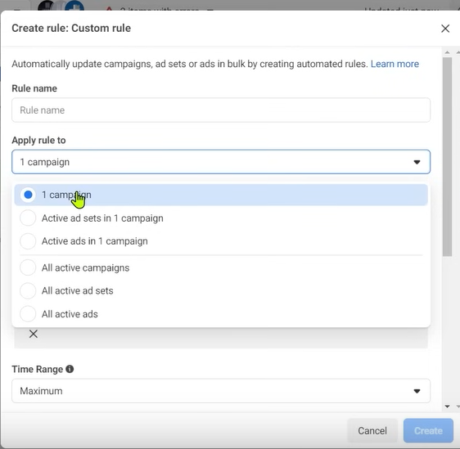

Now you can se the option of 1 campaign as shown above

DO practice and see what case can bring how much optimization

The more practice you do the netter way you can use them inn future

Lesson 74:-

In this lesson we will learn about **Why Facebook Campaign Fails**

We will see many reasons due to which our campaign or ads fails

If we talk about failures then teacher has divided them into two broad categories

One category is that we don’t know anything about facebook system means Facebok ads as a platform we don’t have too much information. WE don’t know how to make ads in facebook and we don’t know how to research our audiences we don’t know how to make ad set structure We don’t know how many ad we need to make

If you don’t know anything at an implementation level that how to implement something in a platform and how to use that platform

What are the different option in the platform

What type of campaign we can make

IN what scenario we should make this campaign

If you don’t have a proper knowledge related to it then you will do the mistake

Now in Second category

Which is strategy level means we know about tools and learn its use

Now we know type of campaign and how many ways we can make ad set aand when how may types of ad set we should make but when it is a time of implementation and when we want to promote any business in facebook ads then

**Phase 100**

Fail to make Strategies we cannot understand how to divide budget and how we should devide our budget into campaign. What campaign of what budget should run . what objective we should run and what should be the KPI of compaign and how we will measyre its success

Suppose we are running a campaign of 5000 rupees then it is necessary to make success kpi of it let say we judhge the campaign on the nasis of cost per convergence or we will judge on the basis of range , impression,app downloads so we have to decide in starting what should be the KPI of our campaign

SO these are the two major reasons due to which our adds may fail

We told above majoe reason but there can be many reasons inside this major reasons

They can be many

You can do a small mistake and your ad may fail

But still we are going to discuss important points that you should keep thid things in your priority and keep sure that you don’t do these things

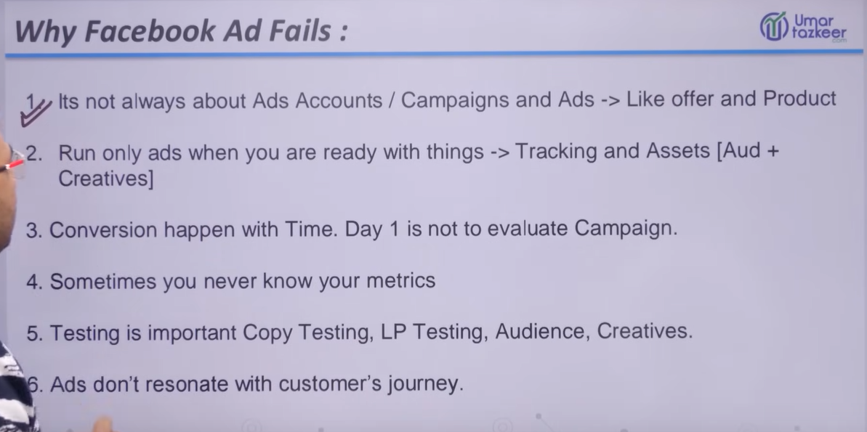

It is seen that people focus on campaign, ads or ads account coinfiguration and strategies but they don’t go beyond that we need to think beyond that and the things beyond that are the offers and services , products that we give

Lets say we are selling a pen

Is there a demand of this pen

If ther is demand then how people want to buy it Does people wan tot nuy it in offer or they want to give more money or if there is a demand of our pen in the market or not

And when it is in demand we have to do research on this as well

Mostly facebook marketer do this they focus on optimization of camapaign and configuration tey are not wrong but the above discussed thing is more important than that

Becaause campaign will only work if your products and services have some value

So first you need to understand your products and services

And understand can buy this pen with offer or it wil be bought without the offer or normally

So oit is more important that does not men you eill neglect the importance of cpmaign strategies

The teacher is saying that offer and service need tb care the most

You have to focus on your product and how to make it and how to present it that this system that strategies itself support it

Now in second option

Things means resources

It is seen that many people run the ad but they do not setup many settings ,trackings they do not setup it

For example there is ecommerce website and in starting you run their ads and you did not seetht the ecommerce related events are being fired or not

Measn you afe not checking viewcontent event is fired or not ot other events also

You did not check are parameters being sent or not

If you did not do all the settings tehn after that how will measure performance on the basis of add to cart it will become challenging

You cannot check that whatever add to cart happened what was their monetory value

When you fire your ad then you need to check these things

If you have not done the tracking and immediately fire the ad then this information will not go to system so make suer you do all the tracking in the starting and adds asset like audience(custom audience + creatives) because it is not a small work you have to do it in detail

You have to make different audiences and creatives

Thitd point is that

Many people thing that today we run the campaign and all the sale s will happen in one day

Lets say you are selling a product of 20000 rupees and a user sees your add

Do you think he will immediately pay 20000 rupees

The buying process is a journey

He will see it and do his own research and do research on your competitor and then do research on your website and if there is confusion then he may call your support team and then he will convert himself it may happen that it will not happen

But will he convert in one day then the chances are very less

What we do is that we run our campaign we see that we have spent 5000 rupees are spent and on the nasis of that we judge that we spent 5000 rupees and we did not get any result

Yes you can give importance to it if your product is impuse in nature means iits monetary value is not more which we call low ticket product or services lik 100 ,200 ,300 etc

Now if the person sees it and think iot is important to him then he will buy it then there on same day you can do ROI or ROS but If you have high ticket service or product then youb should not think about it it is seen immature marketer don’t see result in their campaign then they do many tweaks in their campoaign. Yoou stop that campaign and run other campaign and then later you run pother campaign nd you do changes very frequently in your ad account that is not right so frequent **changes is not recommended** So give time to your campaign and try to understand that according to your service or product how uch time it can take for convergence

You have to understand it

The fourth option is whenever you run the campaign you should know your metrics even if the campaign is of low budget even then you should know your KPI , on what metrics you will judge your campaign

It isn not like that see what will happen

Even if your testing then what are you testing

If you are running a traffic campaign or awreness campaign then awarenees campaign might return some result then wht is the result you expect on the bais of our KPI should be our landing page visits . Is ther landing page visits or not

If we talk about our website traffic example for that The important result for that is there should be some visits on our landing page and our landing page visits should increase

So we will see whether landing page number are increasing or not

So you don’t have to run the capmpaign in hawa(without thinking anything for the prpose of testing(who knows))

**Phase 101**

After running campaign don’t think that our product was bought or not immediately , people enquired about our services or not .Think about the objective of campaign was fulfilled or not

So for that we need to mention our KPI

If you got the hobit of developing KPI thn you will understand that is our campaign are not performing or our strategy is not performing or we are measuring wrong think

The 5th option

Testing is important and it is not about testing about only one element by testing we mean copy testing . Suppose we write primary text in our ads we are talking about testing of primary text see its testing see what will happen if I write short primary text or long primary text or If I write medium primary text Are people loving it and giving response it

There are many variables you can test like headlies, call to action etc

Another testing is Land Page Testing. You can test many thing in Landing Page Now we have many powerful tools like Google Optimisation that help you in implementing many testing

You can also do Audience Testing or Creative Testing

But before testing you should have resources to test like Creative and audience

If you don’t have then how you will test it then you need to create new creatives

Th point is Ad’s are not matching with customer journey

Suppose you make a remarketing audience on the basis of your website visitor so it simple means they have already visited your website . Whatever product or services you are offering they know about it now you are giving the same information to them in your ad copy then why they will click it. They will not click it and then the ad fatigue happens and then your campaign get failed. It means if we are creating remarketing audience then our creative should be of different type and its call to action should be different type. So we need to focus on these things

If focus on these things then our chances of failure of campaign are reduced.

**Lesson 75:-**

In this lesson we will learn about **What is Fbclid in Facebook**

We will see What is Facebook click identifier how it works and why in our url faceook click identifier is shown and how because of it the reports of Google analytics gets changed and How can we solve it. We will discuss it all

Now whenever you browse your feed yow will see many feed some is organic and some is ad.

Id you see any link which is outbounding means moving you outside the facebook

Now you click on link of an ad you will most probably reach the landing page if you see the url then you will notice that

You will see after utm source



Fbclid and there value is encrypted

Why it is bein shown and why facebook is adding it In our url even if you have not used utm parameters tehn still fbclid would be definitely in the url

You will see it in every url which is outbound to facebook

This FBCID launched recently in 2018

And Facebook also does not any notification and did not mention it in documentation wih regard to fbclid never launched it .Facebook use this to identify that how many outbound were clicked and people are going to which website means they needed something by whih they can track back that whick link the user is clicking on to reach which page because fbcluid was added in url some information was gone to facbook system in the similar way facebook use utm parameters for tracking similay for facebook we use fbclid in url and hen because of it some encryted information ow gone to facebook system SO for facebook it is a way to collect data.

If user click on an ad and reach landing page and in thi landing page we have installed our Google Analytics if we have installed google analytics then in google analytis it will be recorded that this landing page was visitedwith fbclid

Now if you see report in google analytics

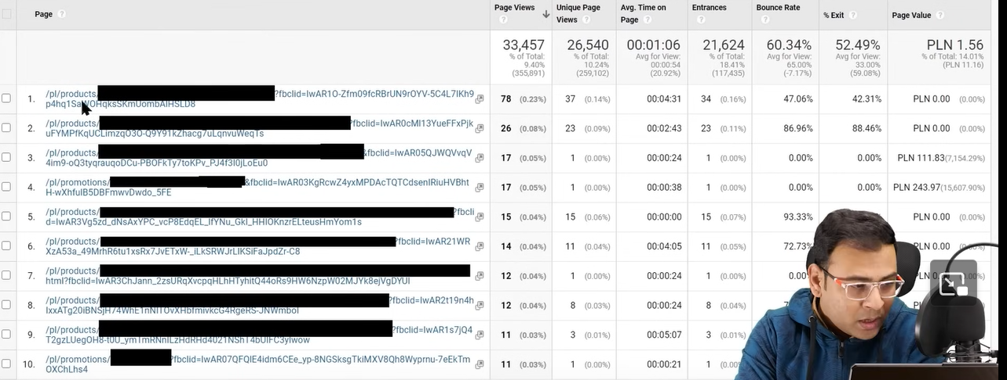

You will see report like above many page parts or path will be formed(I don’t know )

So in google analytics we will face problem in watching our ad we want ot see neat and clean data means if you aer working on google analytics if we talk about ither then fbclid don’t have any harm Fblid is just an identifier due to which on the bassi of url was tracking you it basically collect your data it does not even track

fbclid will not hurt you

but it will distub analytics means makes it more complicated

If you don’t want it in your analyutics

SO for that go to your google analytics and then go to view settings as marked below

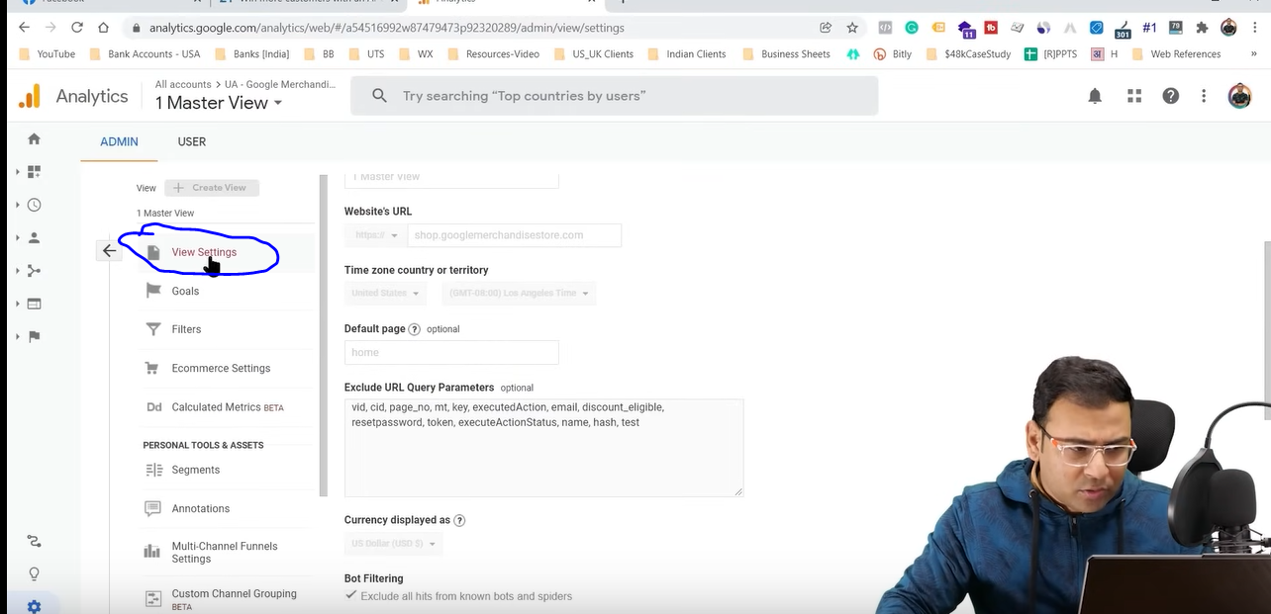

Measn areacj view level and then to Admin

GO to exclude URL Query parameter

Ust mention you r fbclid here

Then click on bone at the bootm of the screen

Now you will not see it in your analytics

**Lesson 76:-**

In this lesson we will learn about **Message Campaign in Facebook**

IN facebook ads we have message type of campaign’s option but there are very less advertiser that run message type of campaign

IN this lesson we will understand it in deail how can we run it and wha are there advantages nad how many ways we can run it some people call it messenger campaign

Nobody can deny that facebook messenger app is most used app but ther are many marketers that instead of this add has not used this type of campaign

In this lesson you will understand the potentialthat how can we use it . It may happen that you use it in future

When you go to facebook ads and go to Campaign creation window and then in under Consideration choose messages

**Phase 102:-**

If you decide to run it then by this you can do two type of things

Inside it you have two option

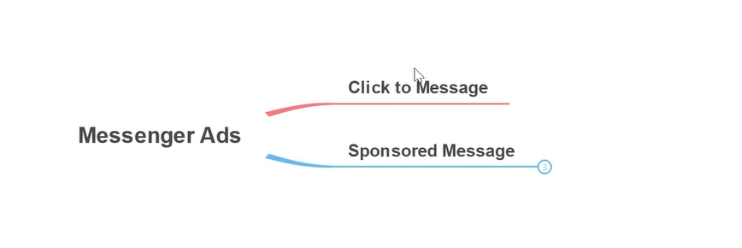

First id click to message which is a type of message campaign

And then the second comes which is Sponsored Message Campaign

We see their major differences first and then we will see how to practicaly create it

By click to message we mean that whenever you run ads in facebook then you have your image as a creative and then below it you have call to action. SO here you can do your audience targeting like you do normally

Now according to the audience you creative your creative and then call to action below it will be click to message or click to messenger. So when the user will click on the call to action button then his messenger will be opened with your contact so that it can start the conversation

Now comes the Sponsored Message

It measn your message is reaching to other messengers means this time you are not showing them ad and click on call to action o open their messenger. This time you are creating your template or sponsored message and you send this message to other people’s messenger so that when they are viewing their messenger then they can see your ad This is actually the sponsored message. If we talk about its speciality then these are a type of retargeting ads

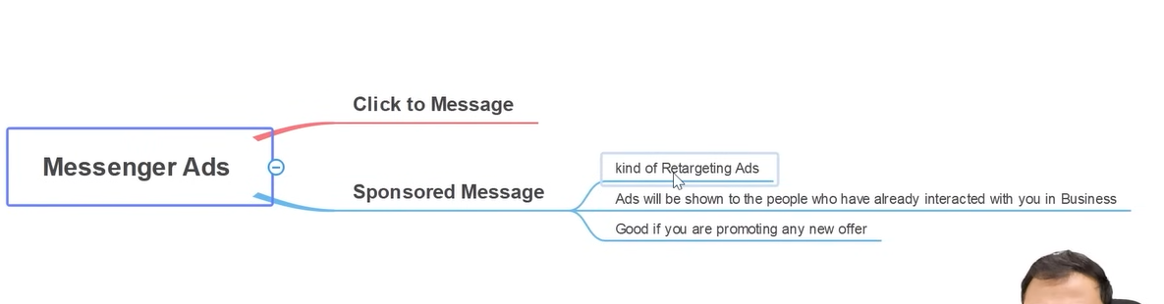This is because you can send this message to those people who have already interacted with you in messenger So what type of message SO what type of promotion you can make here and what type of message you would want to send here . you would want if your are bringing any promotional offer then or you are launching some new coupons or anything you are bringing sales or you are bringing some exciting offer tehn you would want that the people whio interacted with you in messenger we should show them some sponsored ad and we run sponsored type of ad for them

So these are two type of message ad for message campaign

When you make a campaign theen the maessage type of ad you can see in traffic campaoign

IN ad set level you can choose messenger to derive traffic to

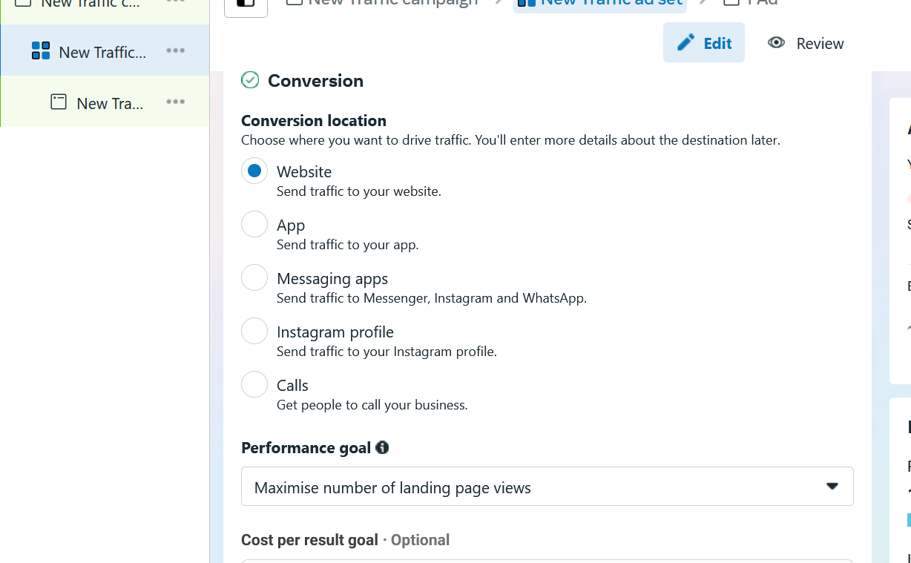

If we choose messages then the ad will be shown to people who have high chances that they will do a conversation with you

In traffic you will get only one option of opening the messenger but in messenger campaign you will get two options as discussed above . Now we will see how to setup it

So we will see from teacher perspective

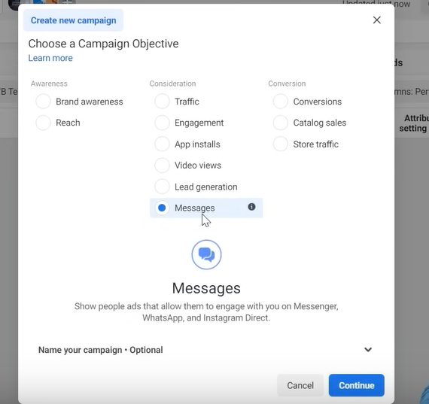

Choose message and then click on continue button

In campaign level tell its name

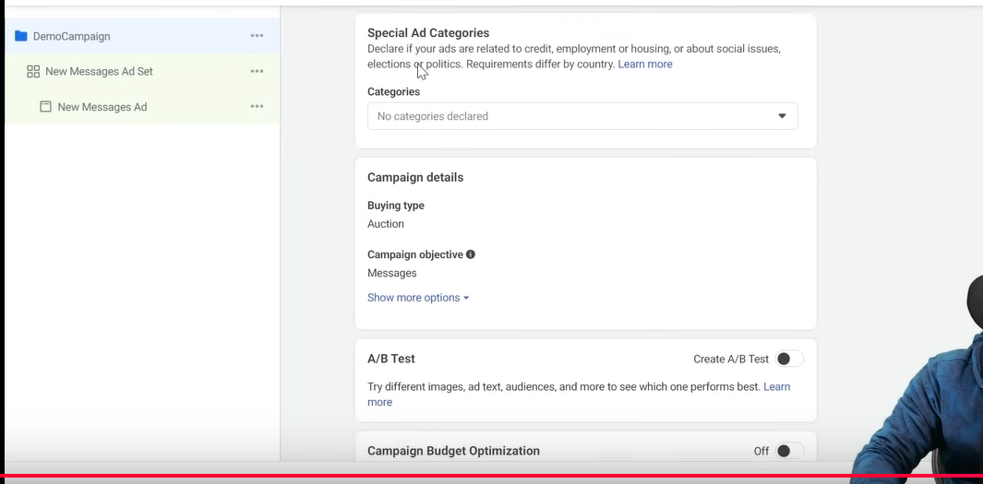

If our ad account have already so much information that and in this particular campaign we are going to create many ad set

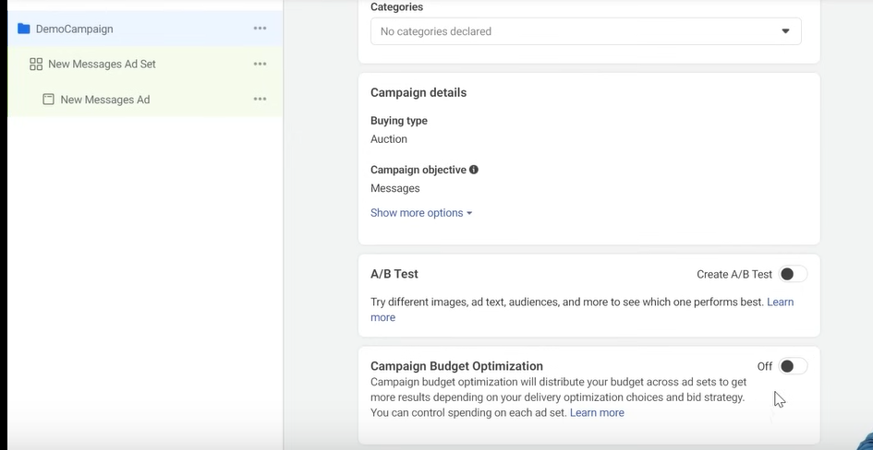

Then we can do campaign Budget optimisation but we will keep it off

Now go to Ad set level

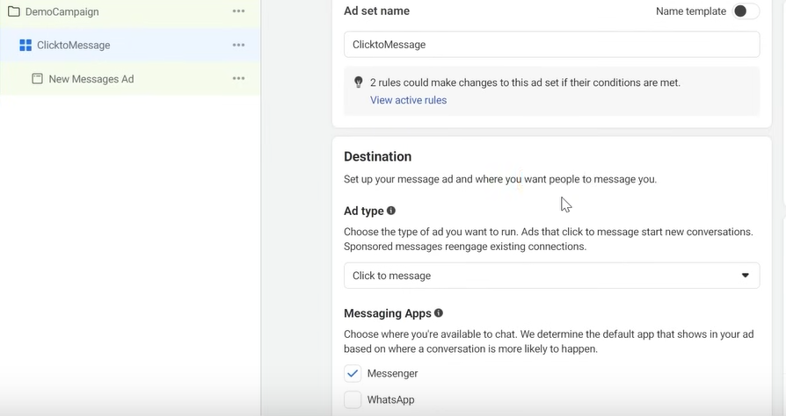In ad type you get two option to tell what type of message ad you want to create

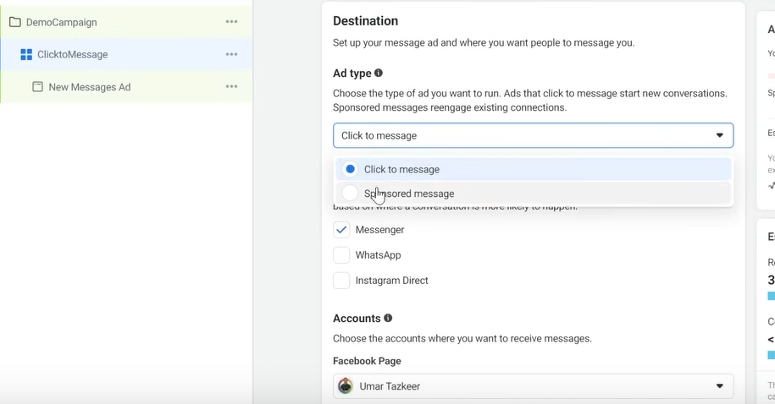

Now below it choose where you want the people to message you

Check the checkbox related to he respected messaginfg technology you can choose all of them then the facebook system will decide what call to action to show to the user that that he click on it and then communicate with you



It is written something like above

Because the primary objective of this particular ad is that your conversation can get started

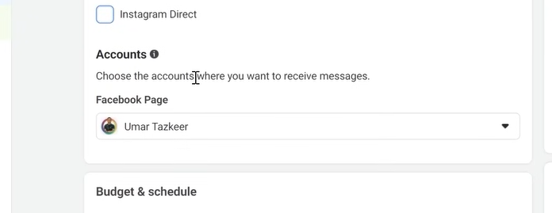

Then you choose what type of page you want to run you can choose the above

We can choose the placement you want

The placement you can choose you get the information if you had already run ads in the past then you can check in your reports that the performance or convergence you get by which placement

Facebook recommend that you run ads in every placemenbt possible but teacer soes not recommend it

Becaue it is seen by teacher that we does not get good result from Audience network

Many impression or cost gets wasted but if you aer choosing audience network and you are not getting any cost in audience network then you can move further move

But if for better optimization we have choosen better audience then he/she don’t usually go for audience network

We want people to converse us and facebook also want this

**Phase 103**

That after watching your ad they interact with your ad and after interacting with it they talk to you in messenger

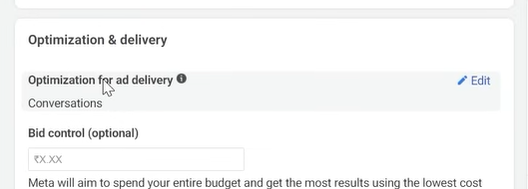

Tht’s why you can see in optimization we have conversations so these campaign are conversation driven campaign

Now if you come to Ad level

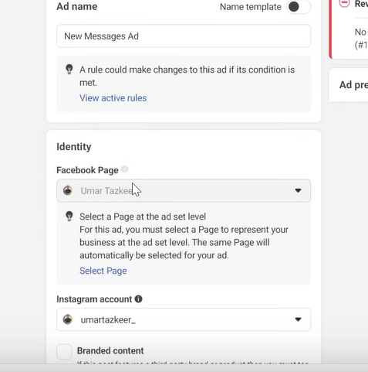

Then it will again ask you the page you want to choose

And then instagram account

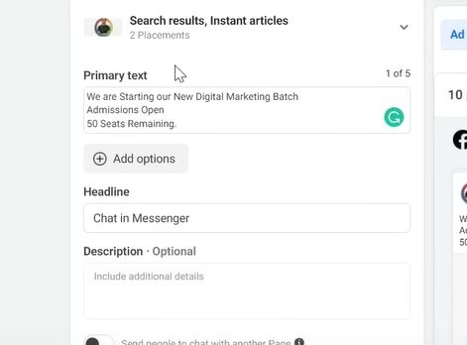

For testing you can add five primary text for testing purposes .The more primary text you add the more facebook has opportunity to test it and the comndition of ad fatigue will be reduced measn ad fatigue will come not fast to them

Similarly you can do so for description

In description you can show time bounded ir fear oof missing out here in description

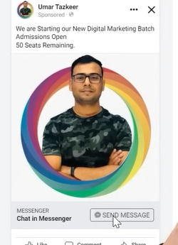

The send message is a call to action

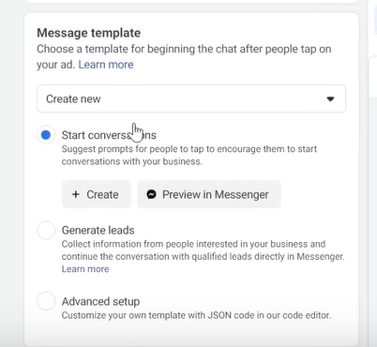

In message template we have an option to start the conversation from our end means we send him a greeting message to them

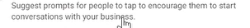

As you can see above the facebook wants that if the person clikcked on the call to action of ad then he reach messenger and after her reaches messenger and he did not type anything then the communication did not start so it says you ask question from your side ad do some prompt

So for that click on create button

And then a window will be opened as shown below

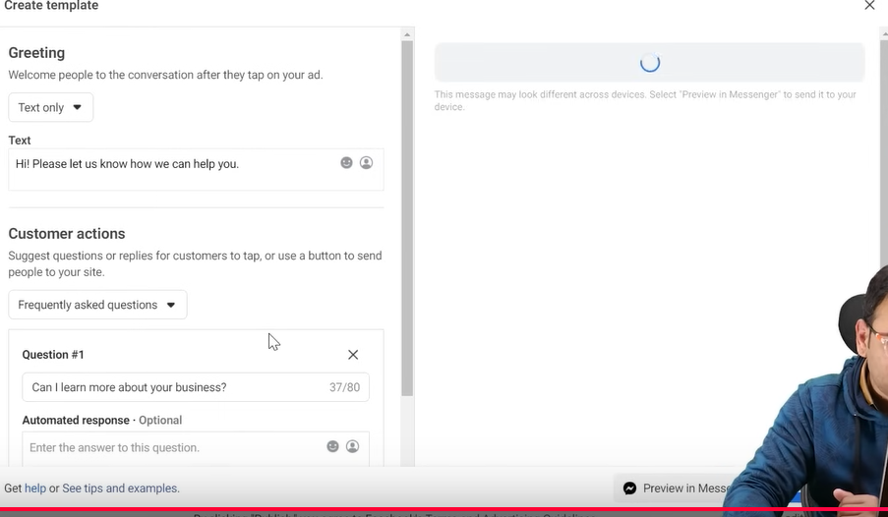

In above you can create your own template

Like we go to Greetings you have chosen text only and you can see it is written the message below it

Here you can design your prompt

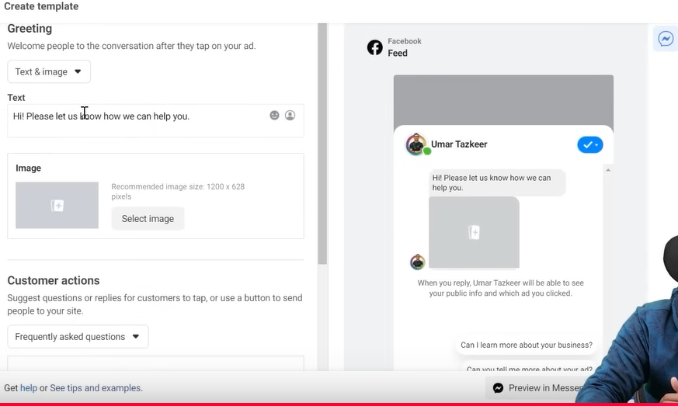

Not only text you can also include text and image

And now on the basis of customer action

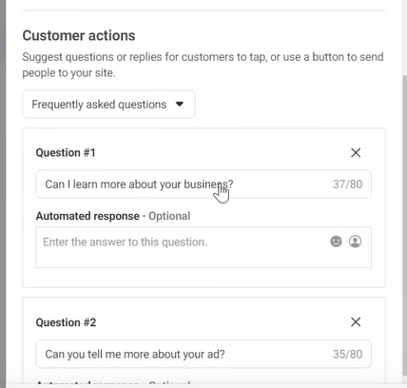

We can ask frequently asked question as shown above

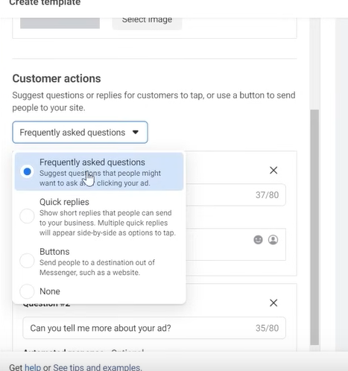

We can give quck replies, Buttons ,FAQ

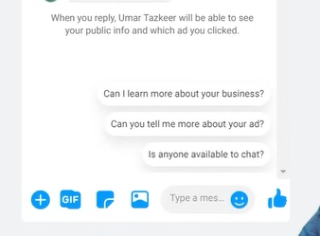

WE are sending him question and we have answered them

So if he chooses any question then he will be answered

So main agenda is that the conversation should be started so in many cases such type of messenger ads are very usefull

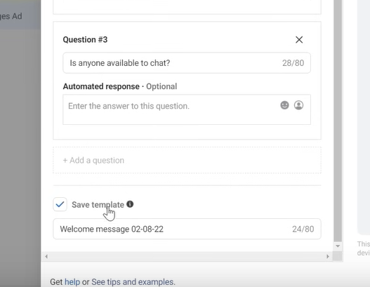

We can name the template and then we can click on save button

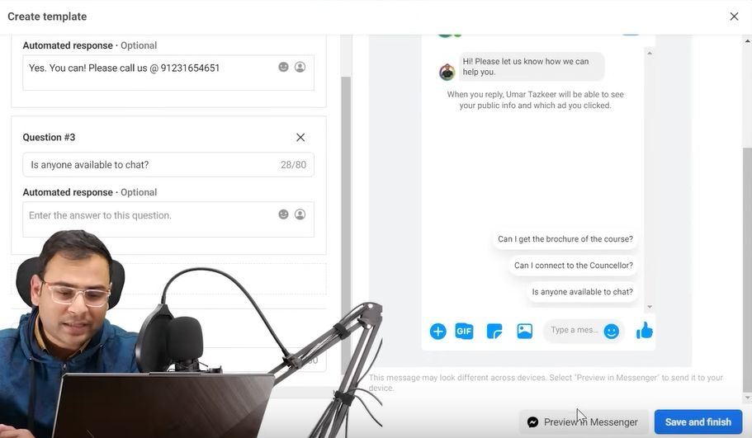

You can click on Save and finish button and or you can click on Preview in Messenger button to preview it in your messenger

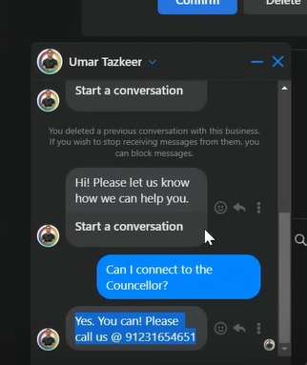

Now you can see it in you r messenger that you click on any question an answer will be answered to you which was written by you while making it

NOw if you want to genereate lead through this message. The lead has basic fundamental that we ask some question from you and you will answer it

SO when someone click on our messenger and reach the messenger then we will not prompt them but we will ask some question from them beacuase lead generation simple means that we ask them their email or conatact number

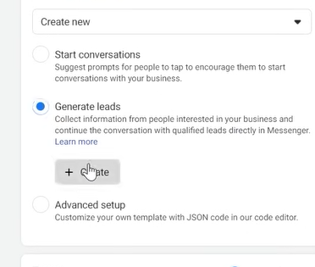

So this time choose Generate lead button and then go to create button

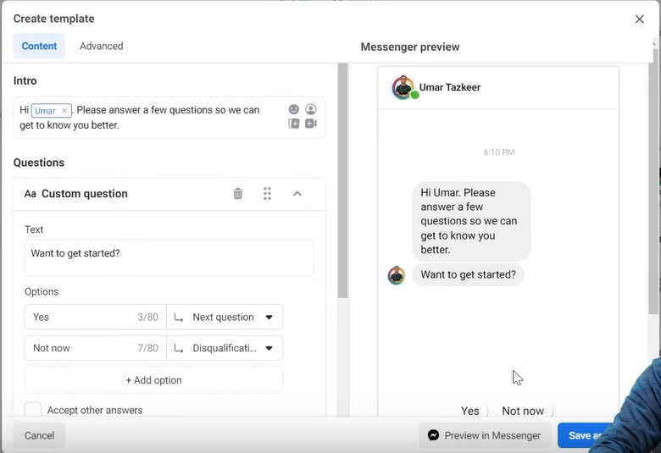

So now a window will open in the preview when the click on yes then you can ask tehm questions

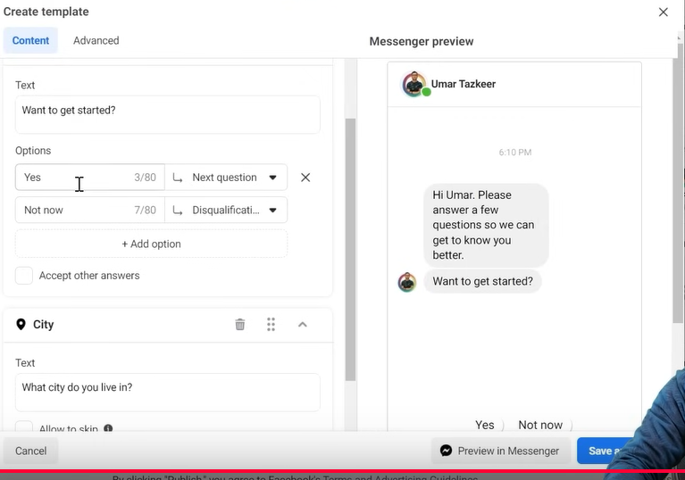

Then we can design our question here in the left side of the window

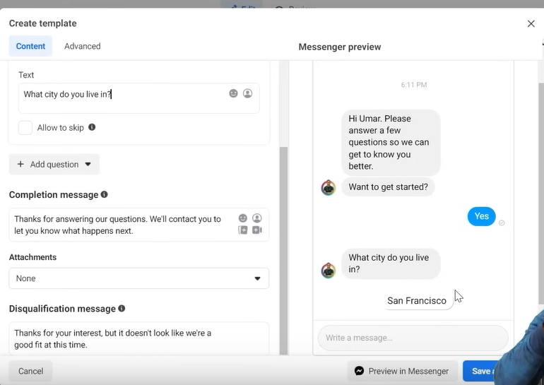

Now after clicking on yes button and then the next question you may ask which city the user live in and then from there profile their city will be prompted which is mentioned in their profile and by such question our lead will be generated

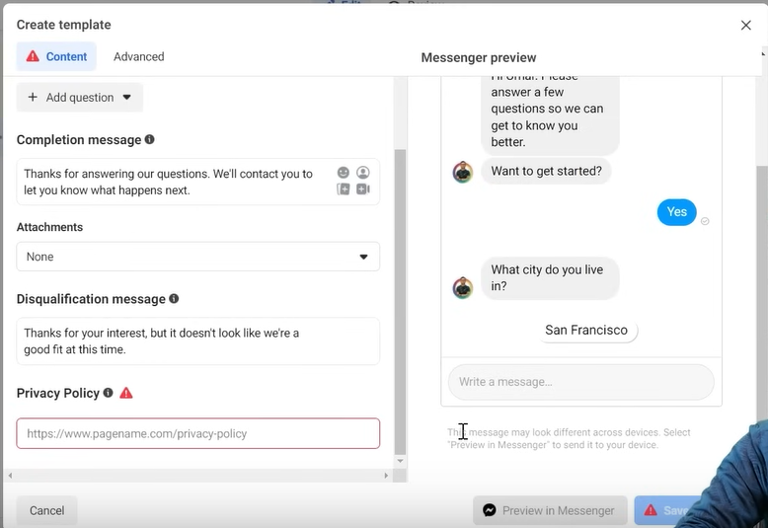

You cannot continue further unless you have your privacy policy now paste it in the privacy policy because without it you cannot capture leads

So in messages ad you get two option one is start conversation or you can generate lead

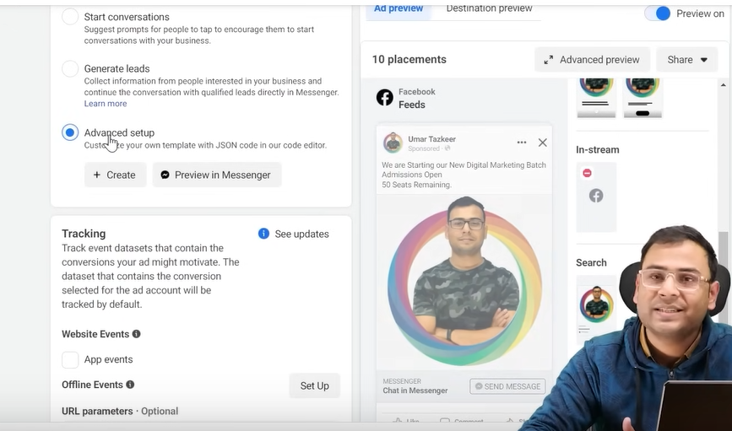

You can choose the advanced setup option so that our facebook messenger is controlled through external bot

Now if you click on create button

Now a new window will be opened

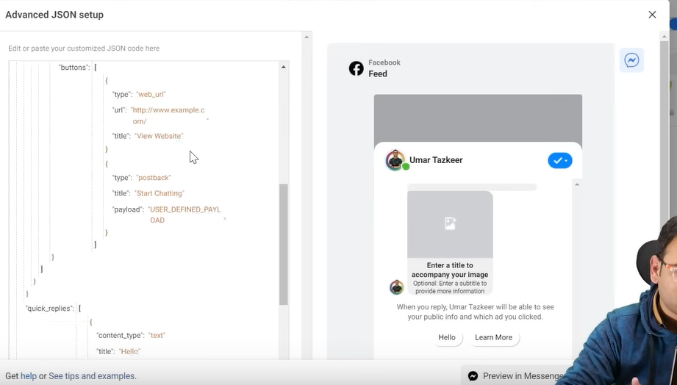

In the left section code you can creat your bot

You can use the code to give the control to external bot like chatfree(ho knows)

If you think you cannot automate many processes then you cannot use a bot

But teacher think that in advance level you will need it

Now we are going to run

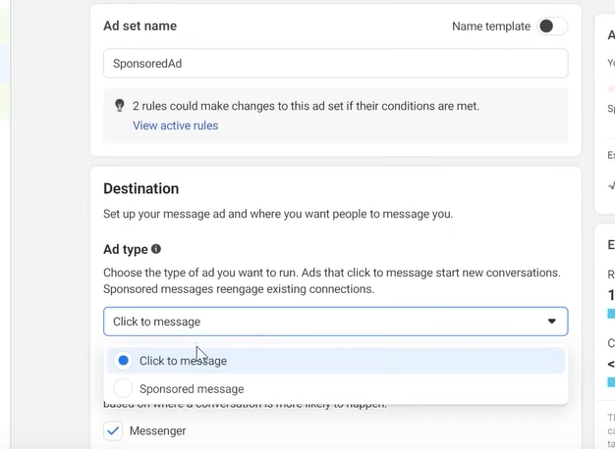

Sponsored ad so this time we choose sponsored message rather than Click to Message

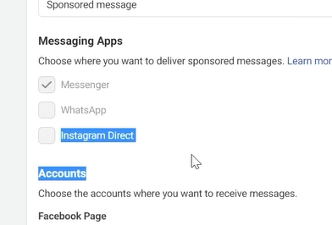

Now you can see that the messenger is valid but Whatsapp and Instagram direct is not possible

As the teacher said that this will work only if you are targeting the people already interacted with you in Messenger so that means tha the audience